ShelfReady – MVP Scope
Oct 21, 2026 · @Aditya Singhal
Problem statement: Founders and ops leads at small packaged-food brands spend 1–3 weeks per launch reworking labels and resubmitting marketplace or retailer listings, because each channel has its own rules on nutrition panels, allergens and claims, and rejections arrive late with vague reasons.
What the evidence supports: a narrower version of this. Bootstrapped food and supplement founders can't get affordable, confident sign-off on claims and allergens before printing, and errors surface late. The "1–3 weeks" figure and the retailer-rejection loop have no support yet. The MVP targets the narrower problem.

1. Problem
Who: bootstrapped founders launching packaged food or supplements without an in-house labeling or regulatory person. Ops leads at small food brands don't appear in the data (GAP – needs research).
- A protein-bar founder working from a commissary kitchen: "I don't have the help of a manufacturer labeling team." (r/foodscience)
- An Amazon supplement seller calls label compliance among "the most stressful and least transparent parts of the business." (r/FulfillmentByAmazon)
- A supplement seller on claim wording: "you don't find out until Amazon flags it months later." (r/FulfillmentByAmazon)
Only quote 1 is from a food brand; quotes 2 and 3 are from supplement sellers.

2. Current State
Today's label workflow has 7 steps, and the compliance checks happen by hand or not at all.
- Formulate, then draft the ingredient statement and nutrition panel (comment).
- Hand the content to a graphic designer to lay out the label (same comment).
- Review the proof for regulatory compliance before printing (same comment).
- Founders without expertise ask around: their food scientist, then Cornell Food Venture (which sent only an FDA link), with a label lawyer as last resort (post).
- Check claims manually, then run copy through a compliance tool (comment).
- Syndicate content to retailers through a PIM, while keeping each retailer's template up to date by hand (review).
- Fix problems after launch when claims that passed initial review get flagged (post).
The resubmission loop after a rejection is a GAP – needs research.
Tool or service | Used for | Source
Truli | Claim risk check | comment
Genesis R&D | Labeling software (training called "super expensive") | post
Salsify PXM | Retailer syndication | G2
ChannelAdvisor/Rithum | Marketplace feeds | G2
Excel | Bulk edits outside the PIM | G2
Prime Label Consultants, NSF, AIB, Registrar Corp | Labeling training | post
Cornell Food Venture, label lawyers | Ad-hoc advice | post

3. Opportunity
The data supports none of the three opportunity numbers yet; the only time figure found contradicts the 1–3 weeks claim.
Measure | What the data says | Source
Frequency of launches | GAP – needs research. One R&D lead launches "quite frequently," no number given | comment
Time per task | About 1% of a working week for an in-house R&D lead who does all labeling. The 1–3 weeks figure is a GAP | comment
Rejection rate | GAP – the search for statistics returned none | Google dataset
Brands affected | GAP – only market value found, not a count of brands | see below
India packaged food market | USD 137.25B (2026) | IMARC
 | USD 142B (2025) | Ken Research
 | USD 80.22B (2024) | LinkedIn
Consumers reading labels | 83% of US consumers read labels before buying | NSF
The market estimates disagree because each source defines "packaged food" differently, and none isolates small brands. Market figures come from search snippets and haven't been checked against the source pages.

4. Solution
ShelfReady checks a draft label against one market's rules before printing, so the founder only pays an expert for what's actually risky. Two of today's steps disappear and two shrink; the founder still signs off.
- Upload recipe, supplier spec sheets, draft label copy and target channel.
- Calculate the nutrition panel and draft the ingredient statement. Replaces today's step 1.
- Flag allergens, including hidden ones (whey or casein under milk), and ask about shared equipment.
- Review claims per channel, each flag with a reason and the cited rule.
  - Disappears: step 4, asking around, for routine questions.
  - Shrinks: step 5, the manual claim check.
- Founder resolves flags: accept a fix, rewrite, or escalate high-risk items to an expert.
- Designer lays out the label. Unchanged.
- Check the final proof against approved text. Step 3 shrinks to a human sign-off.
- Generate listing content in each channel's format.
  - Disappears: step 6's manual template re-mapping and Excel round-trip (review, review).
- Monitor after launch: re-check live labels when a rule changes; turn a vague rejection into a likely cause and fix. Optional, since no rejection cases appeared in the data.

5. AI Thinking
AI handles language and judgment, scripts handle math and validation, and a human signs off. The system never declares a label compliant on its own.
Step | Who | Why this and not something else
1. Upload | Human | Only the founder has the recipe, suppliers and channel plans
2. Nutrition panel | Script | Arithmetic plus fixed rounding rules; it must give the same answer every time, so AI adds risk
2. Ingredient statement | AI, then script | Spec sheets are messy PDFs, so AI extracts sub-ingredients; a script sorts by weight and formats
3. Allergens | Rule, then AI | The allergen list is a rule; mapping "whey protein concentrate" or "natural flavour (contains milk)" to it needs language understanding
4. Claims review | AI | The core case. Implied disease claims can be phrased endlessly (comment), so a banned-word list catches "cures" but misses "supports healthy blood sugar." Experts disagree on edge cases (thread), which needs judgment with stated reasoning
5. Resolve flags | Human | Legal responsibility stays with the brand (post)
6. Design | Human | Creative work, outside scope
7. Proof check | AI, then script | AI reads text off the rendered proof; a script diffs it against approved copy and makes the call
8. Channel listings | AI, then script | Retailer templates change and field names vary (review); AI maps fields, a schema validator checks them
9. Monitoring | Script, then AI | A script detects a rule change; AI summarises which labels it affects and interprets free-text rejections

6. Architecture
One n8n workflow carries a label from the Vercel page through Claude to a report, with every rule pulled from a versioned GitHub pack.
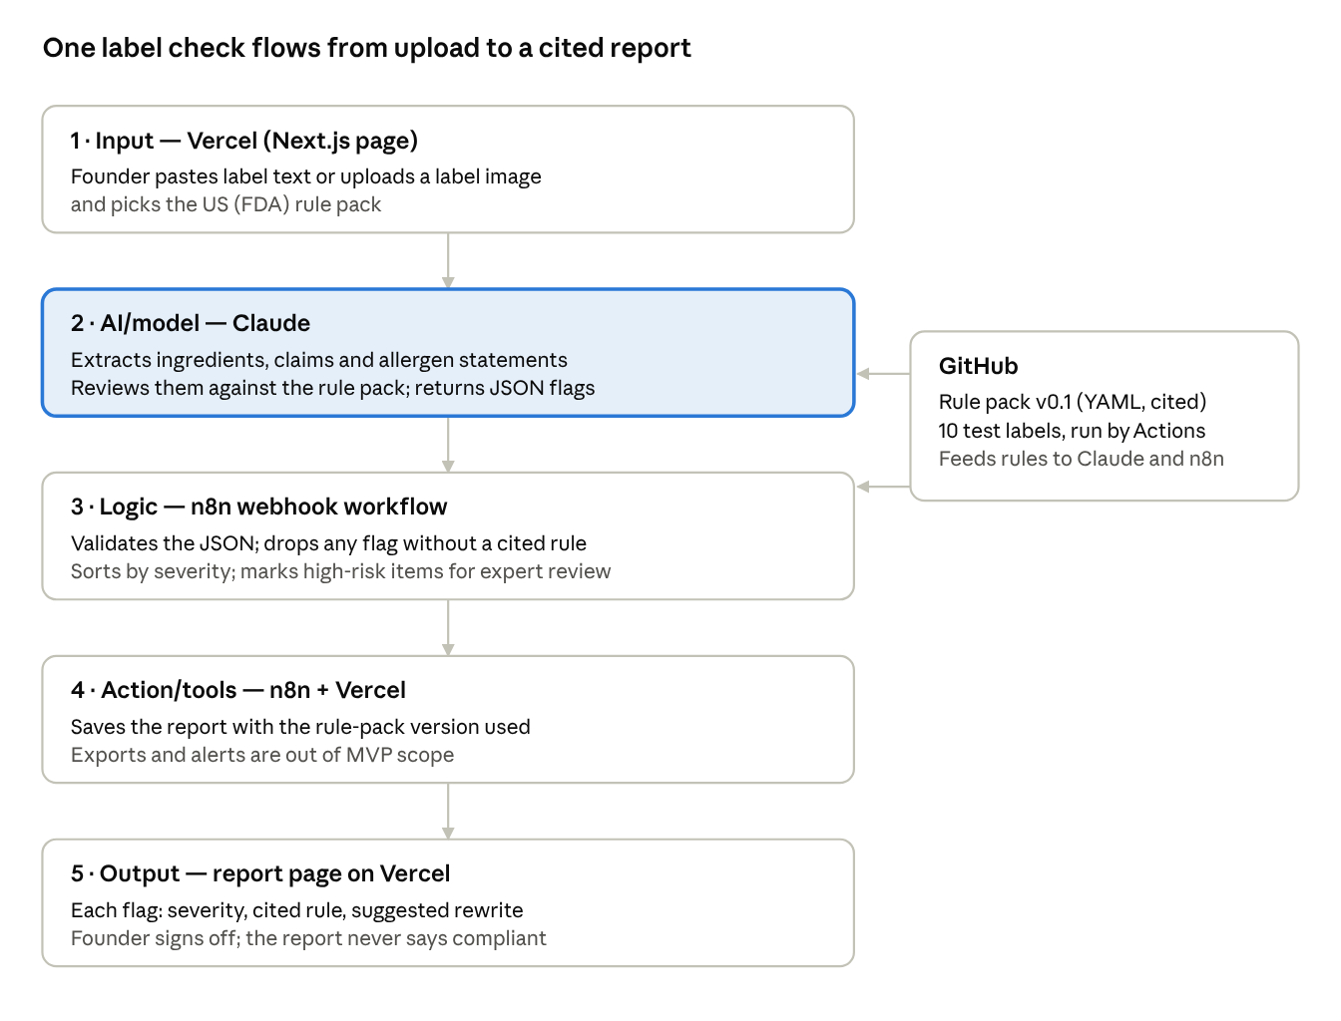
MVP architecture · 5 stages + rule pack
Claude does the reading and judgment; n8n validates its output and drops any flag that doesn't cite a rule; the founder makes the final call.

7. Impact
The evidence-based saving is about 12 minutes a week for teams with an in-house expert; founders without one could save 0.8–4.6 hours a week, but every input to that range is an assumption.
Time saved, scenario A (evidence): an in-house R&D lead spends about 1% of the week on labeling (comment).
0.01 \times 40\text{ h} = 0.4\text{ h/week} \quad\rightarrow\quad 0.4 \times 50\% = 0.2\text{ h} \approx 12\text{ min/week}
Time saved, scenario B (hypothesis): time per launch and launches per year are unverified; the 50% reduction is assumed.
 | Low case | High case
Time per launch | 1 week = 40 h | 3 weeks = 120 h
Launches per year | 2 | 4
Hours per year | 80 h | 480 h
Hours per week (÷ 52) | 1.5 h | 9.2 h
Saved at 50% | ≈ 0.8 h/week | ≈ 4.6 h/week
Quality: every flag cites the rule and rule-pack version it relied on, so the founder and their expert can check the reasoning. How many errors this catches before printing is a GAP – measure it on the test labels.
Scale: one rule pack serves every brand selling in that market, and adding a market means adding a rule pack, not code. Total impact can't be calculated until the number of affected brands is known (GAP).
To validate: in 5–10 founder interviews, ask how many hours their last label took, how many label changes they do per year, and what they paid for outside help.

8. Limitations
The three ways ShelfReady can be confidently wrong are a missed claim, a stale rule and an incomplete allergen picture; a human check sits on each.
Failure case | What a human checks
Missed claim. Claude approves wording that Amazon or a regulator later treats as an implied health claim, the exact pain in the Truli comment | An expert reviews every high-severity flag and every health or "free-from" claim before printing. The tool says "no issues found against rule pack vX," never "compliant"
Stale rule pack. A regulation or channel spec changes and the GitHub pack lags | Each report shows the rule-pack version and when each rule was last verified. An expert approves rule changes through pull requests; packs past their review window are labelled stale
Incomplete allergen picture. A spec sheet omits a sub-ingredient, or cross-contact depends on cleaning the AI can't see (comment) | The founder confirms supplier specs and the co-packer's allergen and cleaning statement. Sign-off is blocked until those questions are answered
Existing tools fall short too: Salsify reviewers report Excel round-trips for bulk edits (review) and constant re-mapping as retailer templates change (review). Genesis Foods has no G2 listing, so its gaps are a GAP.
What to build next, in order:
- Founder interviews to confirm time spent and willingness to pay, before more code.
- Nutrition panel calculator (script, not AI).
- Proof check against approved copy.
- A second rule pack (FSSAI) and per-channel listing export.

9. MVP scope
The MVP is one journey due Oct 22, 2026 at 12:30 PM: paste a label, pick a market, get each risky claim and allergen flagged with the rule it breaks and a safer rewrite.
Core user journey: a founder pastes or uploads draft label text (ingredients, claims, front-of-pack copy) → picks the US (FDA) rule pack → gets a report in under a minute.
IN (build by Thursday, 3 features):
- Label input: paste text or upload a label image; Claude extracts ingredients, claims and allergen statements into fields the founder can correct.
- Claims and allergen check: Claude reviews the extracted text against one seed rule pack (about 15 FDA rules covering major allergens, nutrient-content claims, gluten-free, and disease vs structure/function wording), returning each flag with severity, the cited rule and a suggested rewrite.
- Report: a page listing flags by severity, with the rule-pack version and the line "no issues found against rule pack v0.1," never "compliant."
The US pack goes first because almost all the evidence is US-based (FDA, Amazon). FSSAI is the same code with a different rule pack.
OUT (mention, don't build): nutrition panel calculator, supplier spec-sheet parsing, proof check against artwork, channel listing export, accounts and saved history, payments.
LATER (v2): FSSAI and quick-commerce rule packs (Blinkit, Zepto), Amazon Grocery listing checks, rule-change monitoring with re-checks of live labels, rejection-reason explainer, expert escalation marketplace.
Magic moment: the founder pastes "High protein bar that supports healthy blood sugar" and, within seconds, sees that phrase flagged as an implied disease claim, with the FDA rule cited and a compliant rewrite ready to copy.
Tool | What it does in the MVP
Claude | Extracts label fields from text or image; reviews them against the rule pack; returns structured JSON (flag, severity, rule ID, rewrite)
n8n | One webhook workflow: receive input → fetch the rule pack → call Claude → validate the JSON → return the report
GitHub | Holds the app code, the versioned rule pack (YAML with a source link per rule) and 10 test labels; GitHub Actions run the test labels on every rule change
Vercel | Hosts the Next.js input page and report page, and calls the n8n webhook

Sources
Four Apify datasets back this doc; market figures come from Google snippets and haven't been checked against the source pages.
Dataset | Actor | Items | Dataset ID
Reddit, r/FulfillmentByAmazon (3 queries; run aborted at 11 of 31 pages) | trudax/reddit-scraper-lite | 21 | qYAauh9c0ZH9fRhlV
Reddit, r/foodscience (3 queries) | trudax/reddit-scraper-lite | 40 | QQfnARleuhKk4sxVX
Google, 3 queries, 1 page each | apify/google-search-scraper | 26 organic results | ObXLOrxEA5m6tCL0x
G2, Salsify PXM reviews, lowest rating first | automation-lab/g2-scraper | 20 | V73xY4IOxchE7KGzt
G2 product searches (Genesis Foods, Trustwell, ESHA Genesis R&D, Salsify) and slug guesses | automation-lab/g2-scraper | Genesis Foods not found | NQQ49gM0SJC6E5cjT, kF0wjj8bvsnFppRQh, bIFDf0ltatYebEoG2, DRxjg0KVgwMd542Xl, hRYl6ea4bGEHCJoBu
Reddit links used
- CPG label compliance help!!
- Confusing answers about wheat-free labeling and reply on cross-contact
- Those of you who do food labeling: reply on 1% of the week
- Which food labeling training is best?
- How do you review supplement labels before launch? and Truli reply
- 15 years in CPG packaging: label mistakes
G2 links used
- Salsify PXM reviews: 286508, 94705, 4980703, 12108996
Google results used
- IMARC: India packaged food market
- Ken Research: India packaged food market
- LinkedIn: India packaged food market size
- NSF: Americans demand clarity in food labeling

